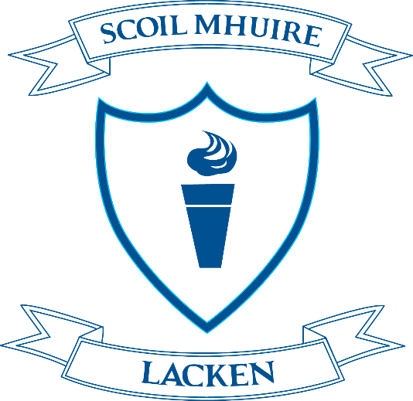

Special Dates and Closures Academic Year 2020/2021

School opens for new term - Thursday, August 27th 2020 at 9.20am

Autumn Midterm Break – School closes on Friday, October 23rd at 3.00pm and reopens on Monday, November 2nd @ 9.20am

Christmas Holidays 2020 – School closes on Tuesday, December 22nd at 12pm and reopens on Wednesday, January 6th, 2021 @9.20am

February Midterm Break 2021 – School closes on Friday, February 12th @ 3.00pm and reopens on Monday, February 22nd @9.20am

St. Patrick’s Day 2021 – School closed on Wednesday, March 17th

Easter Holidays 2021 – School closes on Friday, March 26th at 3.00pm and reopens on Monday, April 12th

May Bank Holiday – School closed on Monday, May 3rd

June Bank Holiday – School closed on Friday June 4th and Monday, June 7th

Summer Holidays 2021 – School closes on Thursday 24th, June at 12pm

These dates are strictly provisional and are subject to change due to unforeseen circumstances or directives from the Department of Education & Skills.

